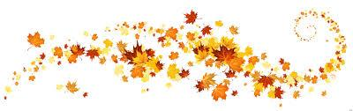
FREMONT PUBLIC LIBRARY’S
SECOND ANNUAL SCARECROW COOKOUT
BUILD COMMUNITY WITH YOUR FRIENDS AND NEIGHBORS
SATURDAY OCTOBER 19
11AM -1PM
RAIN OR SHINE AT THE LIBRARY
ATTENDEES INCLUDE:
THE OPEN SPACE COMMITTEE
THE FIRE DEPARTMENT
THE GARDEN CLUB
THE PTA AND
LITTER FREE FREMONT

FREE BURGERS AND HOT DOGS FROM THE FREMONT LIBRARY ASSOCIATION

THERE WILL BE A FIRE TRUCK AND SCHOOL BUS FOR TOUCH A TRUCK FUN
